# Software Project Management Plan

Team Miaowa Cao

myFarmXchange

May 2017 Revision: 1.0

## Executive Summary

This report tracks the process that Team Miaowa Cao does the myFarmXchange project. The main content for this report is researching how to improve the efficiency of team work and how to make the project be completed better through Agile Scrum. There are four parts presented in this report. Firstly, in the Project Management Plan section, this essay states the workflow which the Team Miaowa Cao follows to do this project, and it also shows the work allocation for all team members. Then, this report presents the list of high-level ‘epic’ User Stories, according to the real requirements from clients, and provides the proposed solution for them in the Narrative Overview section. Moreover, the solution overview part will provide several detailed proposed IT solutions for the first release of the project. Besides this, the concrete low-level tasks will be pointed out in the SDLC section. Finally, there are burndown and burnup diagrams to record the completeness situation of the project.

Table of Contents

Executive Summary 1

1 Introduction 3

1.1 Purpose of Document 3

1.2 Scope of Project 3

1.3 Audience of Document 3

1.4 Limitations of Document 3

2 Project Management Plan using Agile Scrum 5

2.1 Identification of PMP phase 5

2.2 A list of high-level PMP project tasks 5

2.3 A list of decomposed low-level Sprint project tasks with time estimates 6

2.4 Estimation: How to allocate story points 9

2.5 Up to date Agile PMP swimlane chart 10

2.6 Accurate effort 10

2.7 How sprint is progressing by a burnup chart 11

3 Narrative Overview 13

3.1 Feedback 13

3.2 Context from case study 14

3.3 Design problem 14

3.4 Business objectives 14

3.5 Scope of proposed solution 15

3.6 List of high levels “epic” User stories 16

3.7 “Groomed” product backlog list 19

3.8 Stakeholders 21

4 Solution Overview 22

4.1 IT solutions 22

4.2 Business Driver 23

4.3 Sprint Backlog 23

5 Software Development Life Cycle 28

5.1 Team velocity 28

5.2 The first Sprint’s User Stories 28

5.3 Agile SDLC swimlane board 30

5.4 The List of Low-Level User Stories in the First Sprint with Estimated Story Points 30

5.5 Sprint duration, burndown chart 35

5.6 Describe how to monitor progress using a Burndown Chart and scope creep using a Burnup Chart   35

6 SUMMARY 37

Reference： 38

## Introduction

### Purpose of Document

This document formally outlines the project management plan which is used by Team Miaowa Cao during the myFarmXchange Project. It mainly focuses on four sections: Narrative Overview, Solution Overview, Project Management Plan and Software Development Life Cycle which are using Agile Scrum. In these sections, the document tries to present the team structure, project organization, task allocation, managerial and technical processes, and the project schedule in detail to make all of stakeholders engage this project tightly.

### Scope of Project

The scope of this project is limited by three aspects: time, cost and business-value criteria. We only have six weeks to do the envision stage, speculate stage and explore stage, thus we choose to do the tasks with high-value. Moreover, our budget of first six weeks is 14,850 dollars and the sponsorship from the Australia government is just 50,000 dollars, hence we cannot finish all of requirements. As a result, we should firstly complete the tasks with high business-value according to the ranking requirements from clients.

Therefore, according to the time, cost and business-value criteria, the section will be completed in the first sprint includes a database to store data centrally, a user interface for computer, a sophisticated registered system to classify users, a farm activity management system, and a basic socialization mechanism.

### Audience of Document

The intended audiences of the document are all project stakeholders including the founders: Wilma Flint and Barnaby Rubble, the sponsor: Rural Infrastructure Fund, the project supervisors and all team members.

### Limitations of Document

This document is limited by time and resources, since we only have six weeks to finish it. A few sponsorships can be used during this phase to limit budget in reasonable range. Therefore, there are a part of functions to be left in future development.

According to time limitation, it is not enough for us to master Agile Scrum and to know the Project Management Plan very well. As a result, the user interface for IOS as well as Android and several advanced functions for diary-post system cannot be included in the first stage and they will be finished in the following sprints.

In terms of the limitation of resources, Team Miaowa Cao has been limited to access some kinds of resources, such as physical resources and personnel resources during the first part of the project. Requirements from the virtual clients is not explicit, and the material about smart watch is not enough. For this project, only 50,000 dollars will be sponsored by the Rural Infrastructure Fund, so it must be planned strictly. In that case, the function about smart watch and the synchronized system cannot be released in this document.

## Project Management Plan using Agile Scrum

### Identification of PMP phase

As Boehm (1988) stated, the conceptual plan is important for the development of a project. Hence, we should design the scope of the phases in detail and follow it strictly.

Our group divide the project into four phases (Chandana, 2012):

Envision: “identifies customer’s vision of the project, decides the key capabilities required in the project, set the business objectives of the project, identifies the quality objectives of the project, and identifies the right participants and stakeholders of the project and plans how the team will deliver the project.”

Speculate: “the product vision into a backlog of requirements is translated, the overall approach to meet the requirements is realized and a high-level release plan for the product is presented.”

Explore: “explores various alternatives to implement and fulfil the requirements of a project.”

Adapt: “reviews the results of execution, the current situation, performance of the team against the plan and adapt as per the requirements.”

### A list of high-level PMP project tasks

As Agile Alliance (2001) announced, developing projects which need interactions and individuals over processes should coordinate effectively by following a plan. To coordinate effectively, we use the Trello as the tool to do the plan.

In the screenshot 1, each card in a list represents a high-level PMP project task. The lists where we locate our cards are the phases where the tasks are. Also, the labels can be used to distinguish the phases.

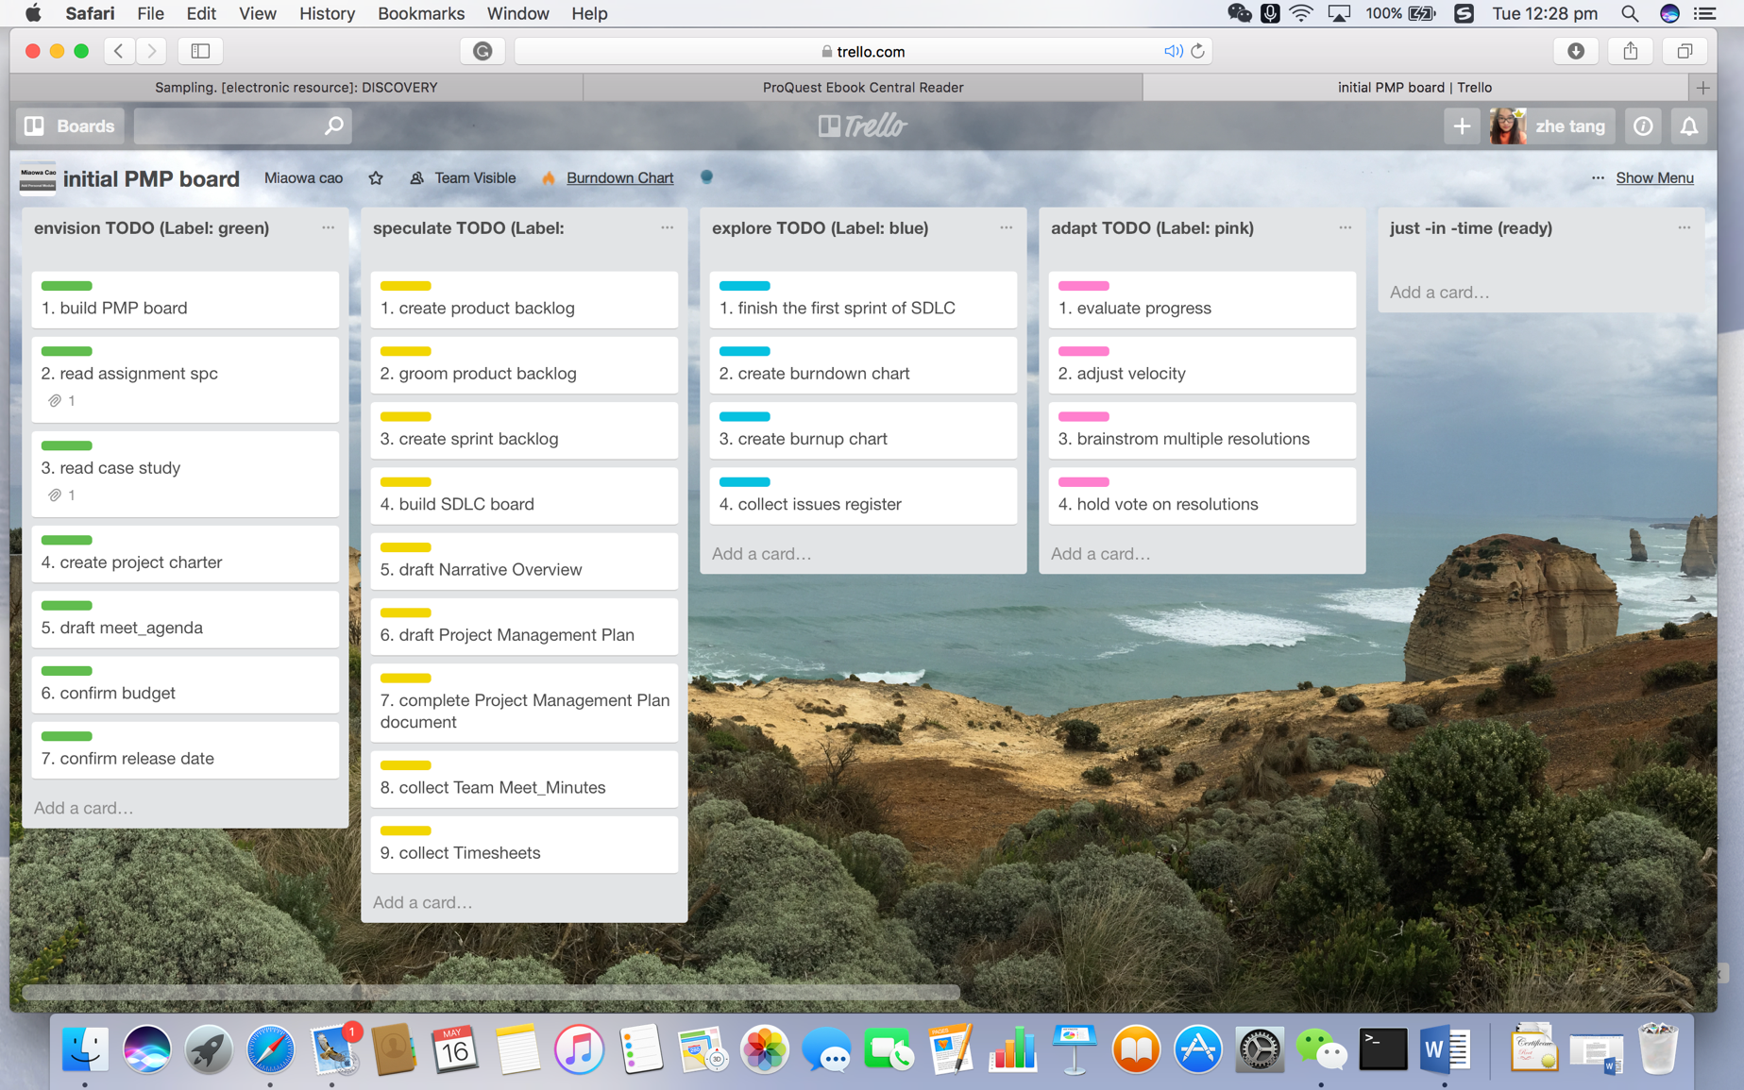

**Screenshot 1 A List of high-level PMP project tasks**

### A list of decomposed low-level Sprint project tasks with time estimates

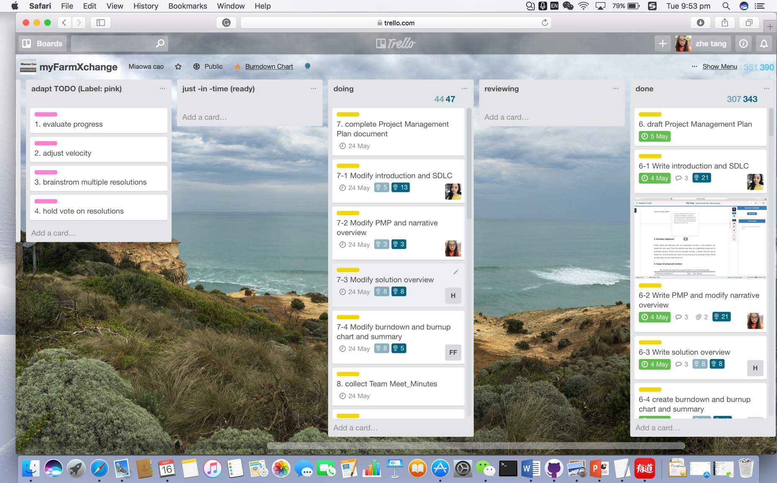

**Screenshot 2 A list of decomposed low-level tasks with time estimates**

|  |  |  |  |
| --- | --- | --- | --- |
| **Stage** | **PM Tasks** | **Low-level PM Tasks** | **Estimated Story Points** |
| Envision | 1. Build PMP board | 1-1 Identify project phase | 13 |
| 1-2 Create a swimlane board and PM task cards | 2 |
| 1-3 Decompose tasks | 13 |
| 1-4 Find references for story point and estimated time | 5 |
| 1-5 Add story points | 5 |
| 1-6 Estimate working time | 5 |
| 2. Read assignment specification | 2-1 Read PMP section and present the structure | 8 |
| 2-2 Read Narrative Overview and introduce the requirements | 8 |
| 2-3 Read solution section and present the structure | 8 |
| 2-4 Read SDLC section and present the structure | 3 |
| 3. Read case study | 3-1 Introduce Social Interaction and Future Enhancements parts to all team | 8 |
| 3-2 Introduce Manual Entry part to all team | 5 |
| 3-3 Introduce diary entries part to all team | 5 |
| 3-4 Introduce background and user profiles part to all team | 5 |
| 4. Create project charter | 4-1 Identify the Project Vision | 3 |
| 4-2 Describe the Project Organization | 1 |
| 4-3 Plan the Approach to Implementation | 5 |
| 4-4 List the Risks and Issues | 5 |
| 5.Draft meet_agenda | 5-1 Find reference to meeting process | 3 |
| 5-2 Identify the phases of meeting | 3 |
| 5-3 Write agenda | 2 |
| 6. Confirm budget | 6-1 Estimate the budget needed | 1 |
| 6-2 Communicate with clients | 1 |
| 7. Confirm release date | 7-1 Estimate the release date of project | 1 |
| 7-2 Negotiate with clients | 1 |
| Speculate | 1. Create product backlog | 1-1 Analysis requirements of clients | 8 |
| 1-2 List all "epic" | 21 |
| 2. Groom product backlog | 2-1 Analyse the data | 5 |
| 2-2 Integrate the learning | 5 |
| 2-3 Decide what to do next | 2 |
| 2-4 Refine the backlog Items | 5 |
| 2-5 Get the High-Priority Items ready | 8 |
| 3. Create sprint backlog | 3-1 Decompose the first 5 epic into User story | 8 |
| 3-2 Decompose the 6-10 epic into User story | 5 |
| 3-3 Decompose the 11-15 epic into User story | 5 |
| 3-4 Decompose the 15-20 epic into User story | 8 |
| 4. Build SDLC board | 4-1 Add backlogs and other list to board | 2 |
| 4-2 Decompose the User story to tasks | 13 |
| 4-3 Find references | 13 |
| 4-4 Estimate and add story point | 8 |
| 5. Draft Narrative Overview | 5-1 Explain context from Case Study | 5 |
| 5-2 Depth of understanding of the design problem | 5 |
| 5-3 Identify business objectives | 5 |
| 5-4 Identify scope of proposed solution | 8 |
| 5-5 Complete list of high-level "epic" User Stories in Product Backlog | 13 |
| 5-6 Create a "groomed" Product Backlog list in client value priority order | 8 |
| 5-7 Identify stakeholders | 1 |
|  | 6. Draft Project Management Plan | 6-1 Write introduction and SDLC | 21 |
| 6-2 Write PMP and modify narrative overview | 21 |
| 6-3 Write solution overview | 8 |
| 6-4 create burndown and burnup chart and summary | 13 |
| 7. Complete Project Management Plan document | 7-1 Modify introduction and SDLC | 13 |
| 7-2 Modify PMP and narrative overview | 3 |
| 7-3 Modify solution overview | 8 |
| 7-4 Modify burndown and burnup chart and summary | 5 |
| 8. Collect Team Meet_Minutes | 8-1 Team Meet_Minutes for week 6 | 2 |
| 8-2 Team Meet_Minutes for week 7 | 1 |
| 8-3 Team Meet_Minutes for break week | 2 |
| 8-4 Team Meet_Minutes for week 8 | 2 |
| 8-5 Team Meet_Minutes for week 9 | 1 |
| 8-6 Team Meet_Minutes for week 10 | 1 |
| 8-7 Team Meet_Minutes for week 11 | 1 |
| 9. Collect Timesheets | 9-1 Timesheets for Fei Teng | 2 |
| 9-2 Timesheets for Haoran Sun | 2 |
| 9-3 Timesheets for Fei Fei | 2 |
| 9-4 Timesheets for Zhe Tang | 2 |
| Explore | 1. Finish the first sprint of SDLC | Cannot do in this project | |
| 2. Create burndown chart | Cannot be done in the first six weeks | |
| 3. Create burnup chart |
| 4. Collect issues register |
| Adapt | 1. Evaluate progress |
| 2. Adjust velocity |
| 3. Brainstrom multiple resolutions |
| 4. Hold vote on resolutions |

**Table 1 Decomposed low-level tasks with time estimates**

### Estimation: How to allocate story points

Our team decides to use Fibonacci numbers as our story points to estimate our PMP tasks. We set the minimum number to be 1 and the maximum number to be 21.

The advantage of Fibonacci numbers over successive natural numbers is that Fibonacci sequence helps us to recognise uncertainty of estimation. For example, it is easier to say 5 is more than 3 than to say 5 is more than 4.

Considering the workloads of our user stories are not that heavy, we think range from 1 to 21 is enough. Because the larger the story point is, the more uncertainty there is (Dan North, 2009).

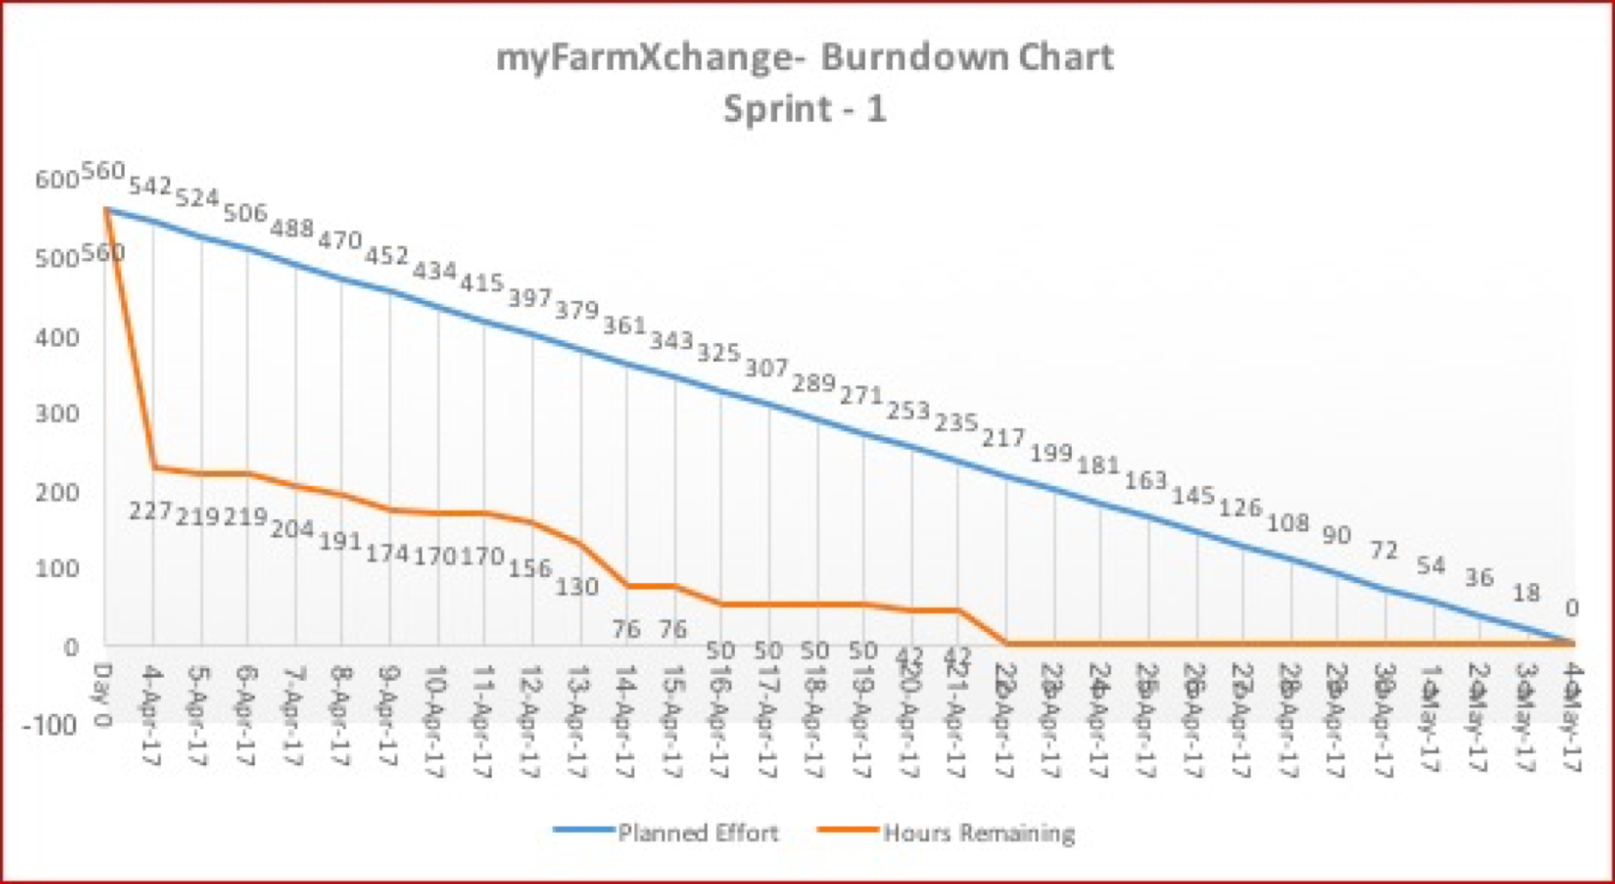

**Chart 1 Estimation of the first sprint**

### Up to date Agile PMP swimlane chart

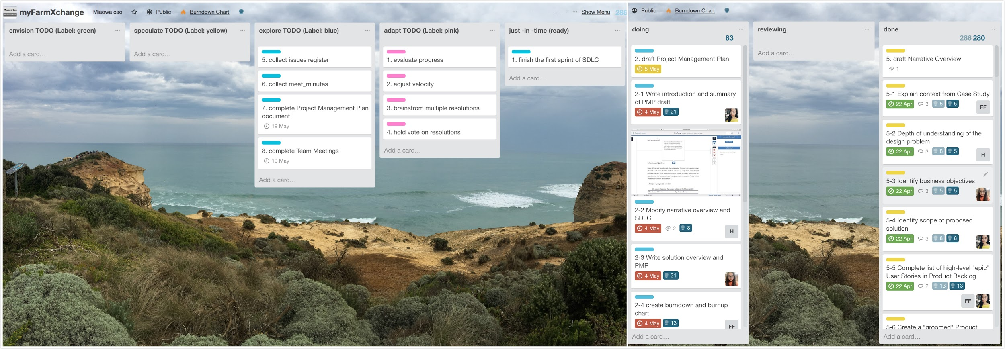

**Screenshot 3 Up to date Agile PMP swimlane chart**

Link: https://trello.com/invite/b/YbVAbYFx/39e8a26c7c68bf2349682fe42e6ef4a8/myfarmxchange

### Accurate effort

There are some differences between the estimated story points and actual ones, which are common in agile. Till now, the total estimation points are 280 with actual points being 280. The largest error in our estimation is the “decompose epics into user story”, which is 8.

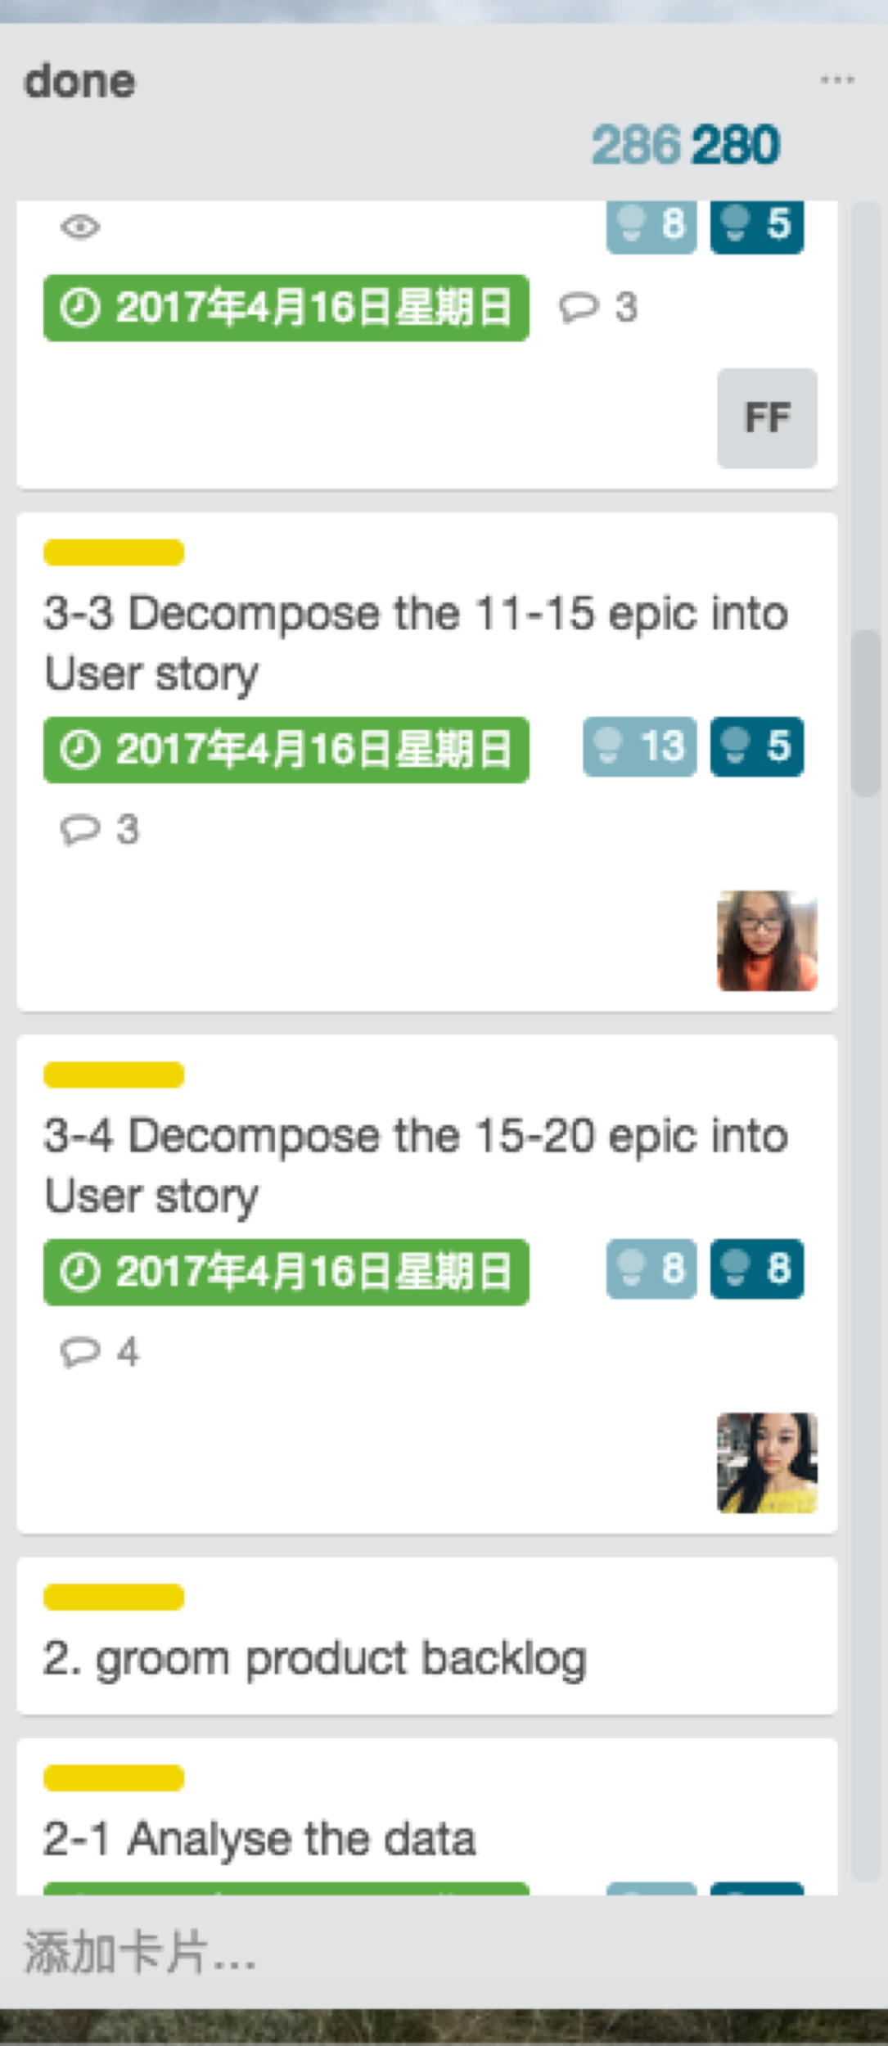

**Screenshot 4 Accurate measurements**

### How sprint is progressing by a burnup chart

A burndown chart combines completed work and total work into one single line, whereas a burnup chart uses two separate lines. It shows more clearly how much work has been done and the total amount of work (http://www.clariostechnology.com/productivity/blog/burnupvsburndownchart).

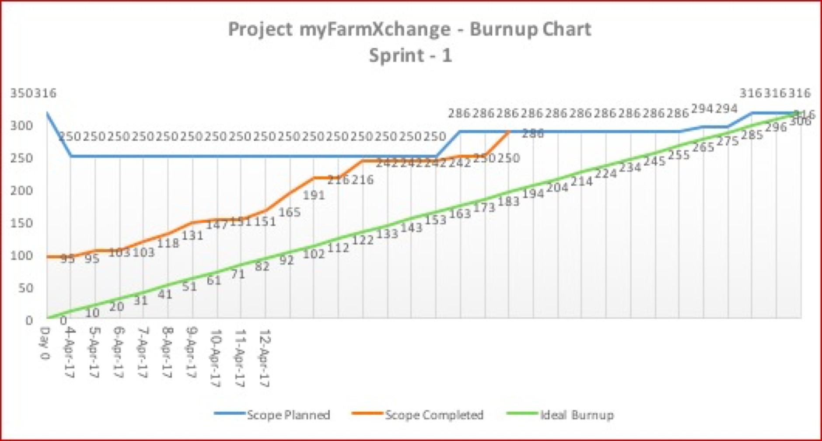

**Chart 2 Process measurement of Sprint**

## Narrative Overview

### Feedback

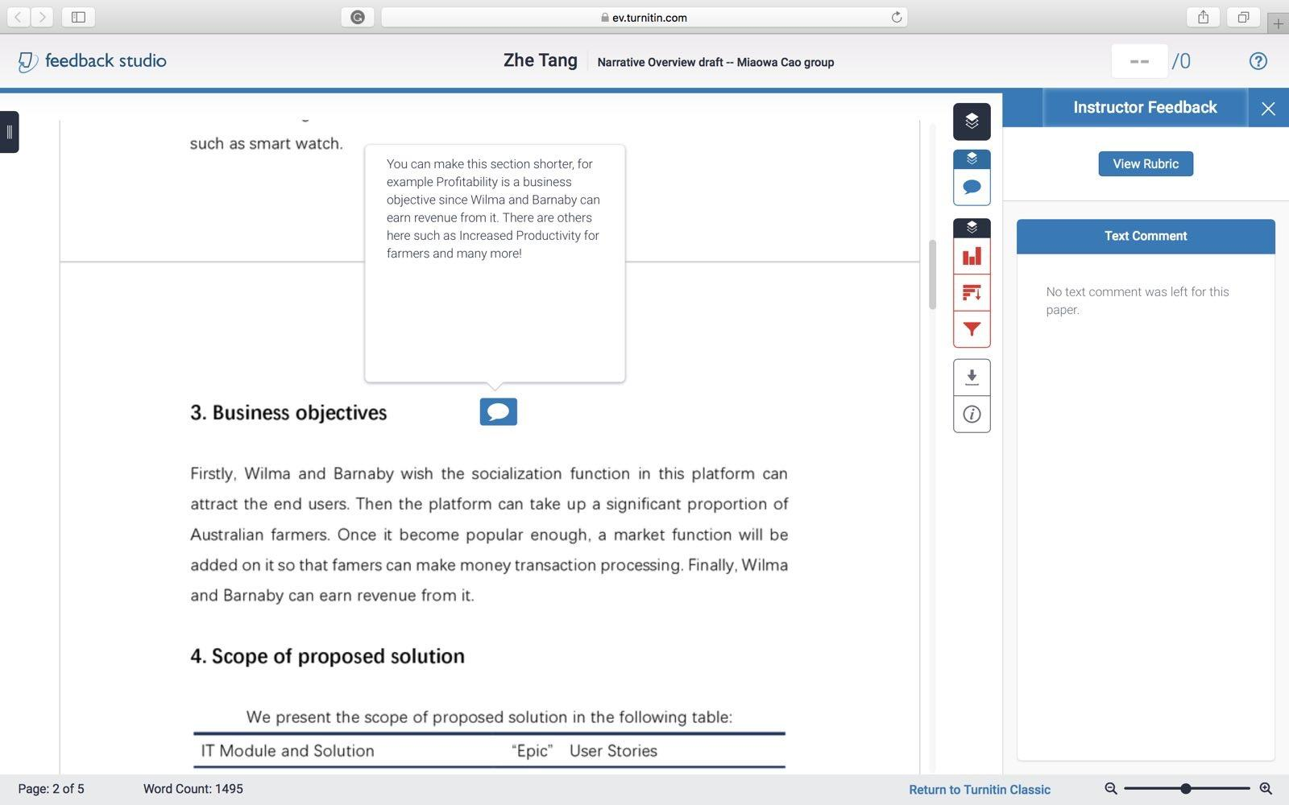

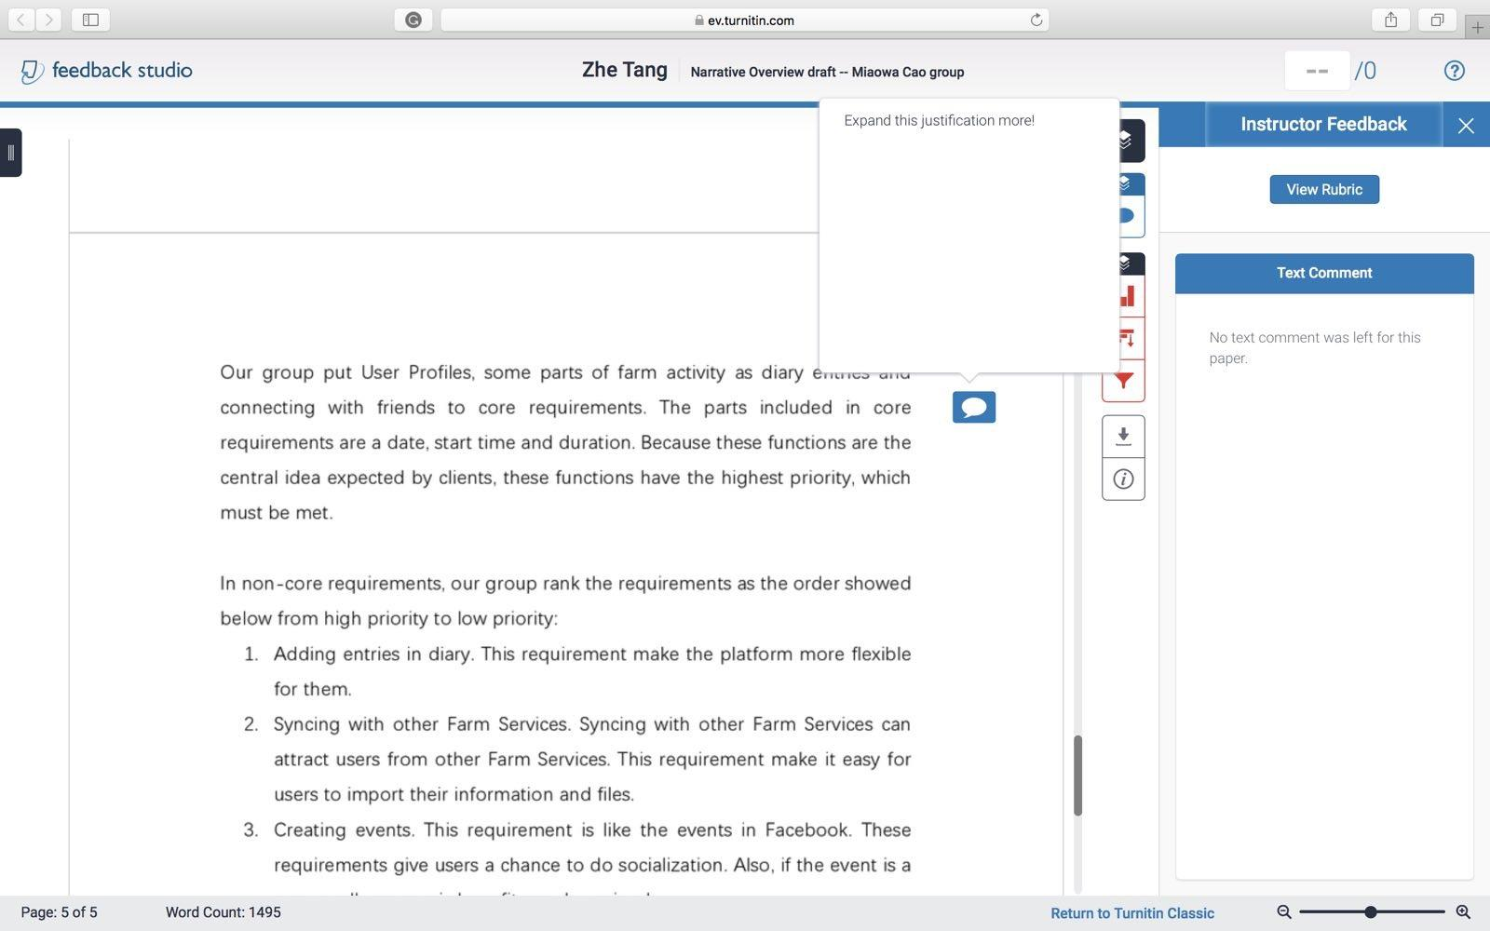

**Screenshot 5 Feedbacks of previous narrative overview**

According to the screenshot 5, our group has made the changes in Business objectives and “groomed” product backlog list. The content in business objectives has been modified. A table is used to show it. Besides this, some evidences in “groomed” product backlog list for why we rank the ‘epic’ have been given.

### Context from case study

Firstly, the case study introduces the background and aim of the MyFarmXchange. Wilman Flint and Barnaby Rubble plan to develop a software named MyFarmXchange. The purpose of this project is to enable farmers to form unified trading blocs to improve farmer’s economic prosperity selling grain and their community connections.

Then, the case study shows the features and requirements of the platform. The platform should include some central functions, like recording farm indicators and socialization between users. It should meet these requirements: User profiles, Diary Entries, Manual Entry, Social Interaction. Also, Wilman Flint and Barnaby Rubble wish this platform can appeal to end users and take up a significant proportion. After the platform is released, revenue may be expected. In the future, Wilma and Barnaby wish this platform can be developed to an “eBay style” transaction processing facility.

### Design problem

This project should be able to run on many different platforms and on many different Operation System. Just see the mobile phone part. There are 3 main different OS on mobile phones, which are IOS, Android and windows. As for browsers, there are even more existing on the world. It may be difficult to match all the browsers or the OS.

Another problem in design may be the size. It is hard to design a properly size of this project. It cannot meet all requirements if the size is too small. And we cannot make it too large because it should be able to be used on small mobile devices such as smart watch.

### Business objectives

|  |  |
| --- | --- |
| **Business objectives** | **Reasons** |
| Profitability | Wilma and Barnaby can earn revenue from it |
| Productivity | Wilma and Barnaby want to produce a social media platform, which can Increase productivity for farmer |
| Competitive Analysis | Wilma and Barnaby see their key differentiator from their competitors as the social media aspect of their vision |
| Increase Market Share | Wilma and Barnaby are hoping the social aspects of the platform appeal to end users and the platform will build up loyalty with a significant proportion of Australian farmers. |
| Core Values | Wilma and Barnaby want to enable farmers to form unified trading blocs, to improve both the farmer’s economic prosperity selling grain and the farmer’s community connections. |
| Growth | Wilma and Barnaby would like to offer an “eBay style” transaction processing facility in the future. |
| Marketing | Wilma and Barnaby want their platform to sync with mobile devices and other farm services, which is like an advertisement. |

**Table 2 Business objectives**

### Scope of proposed solution

We present the scope of proposed solution in the following table:

|  |  |
| --- | --- |
| **IT Module and Solution** | **“Epic” User Stories** |
| Log-in Module | 4 |
| UI Module | 2, 13, 14, 17 |
| Data Type Transfer | 3, 15, 18 |
| Authentication Module | 4, 6 |
| Database Model | 1 |
| Entries Publish and Management | 5, 9, 10, 12, 19 |
| Real-time Location Module | 29 |
| Social Function Module | 6, 7, 8, 11, 12 |
| Information Synchronized | 1, 2, 13, 14, 17, 19, 20, 21, 22, 23, 24, 25, 26, 27, 28, 30, 31 |
| Multiple Account Synchronized | 25, 26, 27, 28, 30, 31 |
| Safety Module | 4, 6 |
| Payment Module | 32 |

**Table 3 Proposed solution**

### List of high levels “epic” User stories

|  |  |
| --- | --- |
| **Action** | **Result** |
| 1.Store all data, resources and information in a database | Resources in platform can be managed |
| 2.Create a website for computer | Computers can be used |
| 3.Transfer the form of data from computer to a unified form | Data from computer can be stored |
| 4.Confirm the identity of registered | Anti-social behaviour can be blocked |
| 5.Build a farm activity management system | Different farm activities can be tracked |
| 6.Build a personal profile page | Personal information can be recorded |
| 7.Build a friendship management system | Socialization can be improved |
| 8.Build a comment system | Social communication can be enhanced |
| 9.Build a concrete farm measurement system | Performance and improvements of farm can be tracked |
| 10.Build an indirect measurement system | Productivity innovations can be fostered |
| 11.Build an attachment system | Videos and photos can be shared |
| 12.Build an event management system | Social interaction can be enhanced |
| 13.Create a mobile application for iOS | Platform can be available from iPhone |
| 14.Create a mobile application for android | Platform can be available from android mobile phone |
| 15. Transfer the form of data from phones to a unified form | Data from phones can be stored |
| 16. Build a text-based diary entries management system | Text-based diary entries can be shared |
| 17.Create an application for smart watch | Platform can be available from smart watch |
| 18.Transfer the form of data from smart watch to a unified form | Data from smart watch can be stored |
| 19.Build a system to publish diary entries automatically | Diary entries captured by mobile devices can be published automatically |
| 20.Create an interface for soil test kits | Measurements from mobile devices can be tracked |
| 21.Create an interface for wireless weather stations | Weather predictions from mobile devices can be tracked |
| 22. Create an interface for fitness tracking wrist bans | The number of steps a person takes a day can be tracked |
| 23. Build an accepted system for data from Mobile Device | Data from mobile device can be uploaded to the platform |
| 24. Build a syncing system for Mobile Device | Data uploaded from mobile device can be synced with the platform |
| 25. Build an accepted system for data from other platforms | Data from other platforms can be uploaded to the platform |
| 26. Build a syncing system for other platforms | Data uploaded from other platforms can be synced with the platform |
| 27.Create an interface for Australian Crop Forecaster | Weather predictions data from Australian Crop Forecaster can be accepted |
| 28.Create an interface for FitBit | Lifestyle and fitness data from FitBit can be accepted |
| 29.Build a GPS receiving system | Location can be recorded |
| 30.Create interfaces for GrainCorp | Transaction data from GrainCrop can be accepted |
| 31. Create interfaces for ProFarmer | Transaction data from ProFarmer can be accepted |
| 32.Create an interface for payment | Payment can be processed |

**Table 4 A list of ‘epic’**

### “Groomed” product backlog list

The requirements in this platform can be divided into two parts: core requirements and non-core requirements.

Our group puts the first 15 ‘epic’ into the core requirements, which are in the first release backlog. This backlog includes the basic functions that Wilman Flint and Barnaby Rubble wish in their platform. Firstly, a central database is needed, because we need this to store all data, resources and information. Then we need an UI and data transfer system for computer, where the basic platform locates. For using the basic platform, register management system is important to confirm the identity of registered, which can distinguish the limitations of users. Also, the central idea of the platform is for people to be able to record farm indicators in a ‘diary’. Therefore, a farm activities management system is built to manage the farm indicators. “Over time, users will be able to see how their farm has performed and track improvements. While there are similar platforms currently available, Wilma and Barnaby see their key differentiator from their competitors as the social media aspect of their vision.” Hence, we build some social interactions system, consisting of personal profile page, friendship management system and a comment system. These actions above are in the first sprint by our group.

After that, some functions, which are less important than the functions in the first sprint, are added into the second Sprint. Firstly, we almost finish the functions of diary entries, by building a concrete farm measurement, an indirect measurement system and an attachment system. Then, we would like to build an event management system to enhance the social interaction. Finally, we meet the requirements that the platform allows users to access the platform from the various devices, apps, browsers and other online services, by creating UI and data transfer system for phones.

In non-core requirements, our group rank the requirements as the order showed below from high priority to low priority:

1. Build a text-based diary entries management system

2. Create an application for smart watch.

3. Transfer the form of data from smart watch to a unified form

4. Build a system to publish diary entries automatically

5. Create an interface for soil test kits

6. Create an interface for wireless weather stations

7. Create an interface for fitness tracking wrist bans

8. Build an accepted system for data from Mobile Device

9. Build a syncing system for Mobile Device

10. Build an accepted system for data from other platforms

11. Build a syncing system for other platforms

12. Create an interface for Australian Crop Forecaster

13. Create an interface for FitBit

14. Build a GPS receiving system

15. Create interfaces for GrainCorp

16. Create interfaces for ProFarmer

17. Create an interface for payment

The reason why we put the requirements into non-core requirements is that these requirements are the improvement requirements of the platform instead of the basic requirements. We rank the requirements through the importance of ‘epic’. Firstly, we build a text-based diary entries management system to add text-based diary entries by users. Also, an application and data transform system are created for users to use smart watch. Then, the platform can be improved by letting the platform sync with mobile devices and other farm services. Moreover, we can build a GPS receiving system that give users an option to receive a standard GPS file format. Lastly, an interface for payment is for future enhancements.

### Stakeholders

Stakeholders should be Wilma Flint and Barnaby Rubble, the sponsor “Rural Infrastructure Fund”, the project supervisors and all team members.

## Solution Overview

### IT solutions

The software will provide a platform for farmers to communicate. We will have many problems while we handle this project, so we need some solutions. This platform will provide a database to support farmers’ data records and provide different APIs for different roles to use this platform.

The myFarmXchange consists of many components, as shown below:

NGR Store Database

Central Database

Computers

Phones

Logical Layer

**Figure 1 High-level architecture of myFarmXchange**

**Computer Webpage**

This part will be developed by HTML and CSS. The image interface will be organized by HTML. The simple logical part consists of CSS code. They will provide a user interface for the user. With the ability to connect with central database, it provides a API for user to store their data.

**Logical Layer**

This part will handle logical operations with JAVA code. It will block some operations from users without NGR. It will handle the translation part including function of opening sockets and the function unifying data. This part will provide a safe environment for users and guarantee the translation process.

**Central Database**

Our database has two parts, which are hardware part and software part. In the software part, we use MySQL as software language. MySQL is a kind of relational database, so it is a stable database. Also, it has a good scalability. These features enable us to adjust the database, when the number of users increase, rather than replace it.

**Mobile device**

We will develop this part using JavaScript because This develop language is supported by all operation system. There are many different mobile device operation systems, so we need to develop them separately. By using JavaScript, we can develop APP in each kind of devices.

### Business Driver

We provide the central database so it can get data and store what we want to reserve. The database can give farmers information when they want. We also provide many different APIs so that farmers can connect to our platform on different devices. The logical layer code could provide a full-featured platform. Moreover, Computer webpage could enable farmers do operations on the platform. All this could provide them a convenient life, so more farmers would like to use our platform. The more they use, the more we will earn.

Considering the importance of sociality to human, we also provide a friend system. This function could help us keep the users. What’s more, they may recommend their friends to use this platform, which can help us save cost on advertising.

### Sprint Backlog

In the first sprint, we would like to complete the epic below:

|  |  |
| --- | --- |
| Action | Result |
| 1.Store all data, resources and information in a database | Resources in platform can be managed |
| 2.Create a website for computer | Computers can be used |
| 3.Transfer the form of data from computer to a unified form | Data from computer can be stored |
| 4.Confirm the identity of registered | Anti-social behavior can be blocked |
| 5.Build a farm activity management system | Different farm activities can be tracked |
| 6.Build a personal profile page | Personal information can be recorded |
| 7.Build a friendship management system | Socialization can be improved |
| 8.Build a comment system | Social communication can be enhanced |
| 9.Build a concrete farm measurement system | Performance and improvements of farm can be tracked |
| 10.Build an indirect measurement system | Productivity innovations can be fostered |
| 11. Build an attachment system | Videos and photos can be shared. |
| 12.Build an event management system | Social interaction can be enhanced. |
| 13. Create a mobile application for iOS | Platform can be available from iPhone |
| 14.Create a mobile application for android | Platform can be available from android mobile phone |
| 15.Transfer the form of data from phones to a unified form | Data from phones can be stored |

**Table 4 ‘Epic’ in the first Sprint**

The user stories of these epics are below:

1.1 As an administrator, I want all data stored in one place so that I can manage them easily.

1.2 As a user, I want my all records to be stored so that I can track my data.

1.3 As a user, I want to send and receive my data quickly so that I will not wait for a long time

1.4 As a user, I want all my data to be consistent so that I will not get wrong data.

2.1 As an administrator, I want the platform can be reached from computer web page so that I can manage the platform on my computer.

2.2 As a user, I want to access the platform through my computer so that I can do operations using my computer.

3.1 As an administrator, I want the form of all data to be unified so that the database can be easily maintained.

3.2 As a user, I want the form of all data to be unified so that the system can be more reliable.

4.1 As an administrator, I want users to be divided into active members and observers so that I can manage their limitations.

4.2 As an administrator, I want active users to provide a valid NGR number so that posts will not be anonymous.

4.3 As a user, I want to have an option to be an observer so that I can see others’ diary entries.

4.4 As a user, I want to have an option to be an active user providing my official NGR number so that I can create entries.

5.1 As an administrator, I want to manage all farm activities so that illegal activities can be blocked.

5.2 As a user, I want to be able to publish my farm activities so that I can see how my farm has performed.

5.3 As a user, I want farm activities to be recorded so that I can track the activities.

6.1 As an administrator, I want to record users’ profile so that I can manage the information of users.

6.2 As a user, I want to be able to publish my personal detail so that others can realize me.

6.3 As a user, I want to see other’s personal profile so that I can decide whether I will accept the friend requests.

7.1 As an administrator, I want to record friendship between users so that I can manage the connection between users.

7.2 As a user, I want to search for and connect with other users so that I can see other’s diary entries.

7.3 As a user, I want to decide whether I will approve the request so that security can be improved.

7.4 As a user, I want to have options to delete connection so that I can end a relationship.

7.5 As a user, I want to have options to report others so that anti-social behaviour can be blocked.

8.1 As an administrator, I want to record comments made between users so that offending users can be removed from the platform.

8.2 As a user, I want to comment on others’ entries so that I can have social interaction with others.

8.3 As a user, I want to see others’ comments on my diary entries so that I can review my work.

9.1 As a user, I want to be able to record my concrete farm measurement so that I can see what I have improved on my farm

9.2 As a user, I want to see the record of my concrete farm measurement so that I can see how I performed this year

10.1 As a user, I want to be able to record my indirect measurement so that I can track my operations in innovation.

10.2 As a user, I want to track my indirect measurement so that I can know what else I could improve.

11.1 As a user, I want to attach videos and pictures on comment so that I share these with my friends.

11.2 As a user, I want the comments to have videos and pictures so that I can be shared with others’ videos and pictures.

12.1 As a user, I want to publish events so that I can invite my connections to attend.

12.2 As a user, I want to have an event management system so that I can be invited to attend my connections’ event.

12.3 As a user, I want to comment on my connections’ event so that others can know the condition of this event.

13.1 As a user, I want to access the platform on my Iphone so that I can do operations through my phone.

13.2 As a user, I want to record and read data using my iphone so that I can track my data while I am outside.

14.1 As a user, I want to access the platform on my android phones so that I can do operations through my phone

14.2 As a user, I want to record and read data using my android phones so that I can track my data while I am outside

15.1 As an administrator, I want to modify the form of data from phone to be unified, so that the database will not crush.

15.2 As a user, I want the data to be transferred to central database successfully so that my data will not be lost

## Software Development Life Cycle

The Team Miaowa Cao utilises Agile Scrum to develop the myFarmXchange project. It is the most appropriate model for this project due to two main reasons. The first one is efficiency. Li, Moe, and Dyba (2010) presents that the agile-based model can overcome a variety of criticized shortcomings of traditional SDLC models. The second is that using Agile model can get a higher productivity by providing the greater flexibility (Cardozo, Neto, Barza, Franca, & da Dilva, 2010).

### Team velocity

We use the same story-points-allocation policy as in PMP tasks, therefore, team velocity could be estimated from there. As is shown in chart 3, which is another version of burnup chart, we infer that we could complete 90 points in a week.

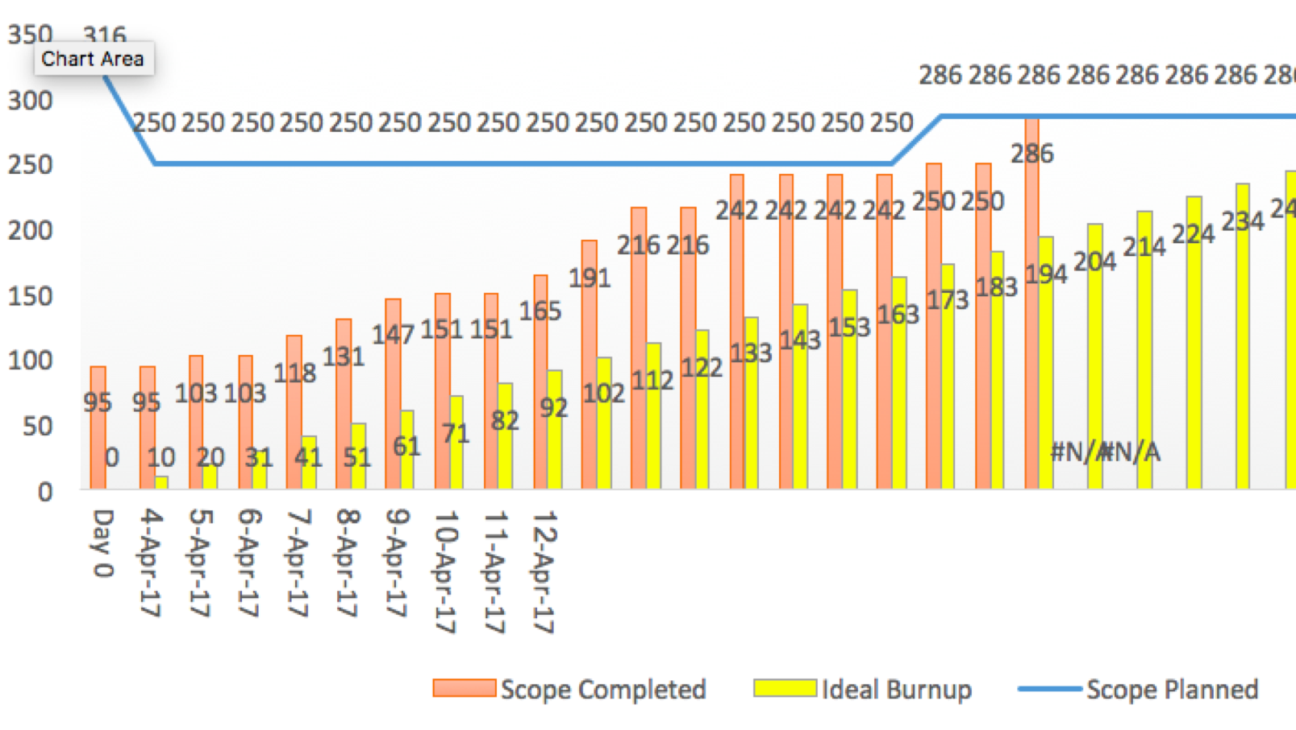

**Chart 3 Team velocity**

### The first Sprint’s User Stories

The list of User Stories in Sprint Backlog:

1.1 As an administrator, I want all data stored in one place so that I can manage them easily.

1.2 As a user, I want my all records to be stored so that I can track my data.

1.3 As a user, I want to send and receive my data quickly so that I will not wait for a long time

1.4 As a user, I want all my data to be consistent so that I will not get wrong data.

2.1 As an administrator, I want the platform can be reached from computer web page so that I can manage the platform on my computer.

2.2 As a user, I want to access the platform through my computer so that I can do operations using my computer.

3.1 As an administrator, I want the form of all data to be unified so that the database can be easily maintained.

3.2 As a user, I want the form of all data to be unified so that the system can be more reliable.

4.1 As an administrator, I want users to be divided into active members and observers so that I can manage their limitations.

4.2 As an administrator, I want active users to provide a valid NGR number so that posts will not be anonymous.

4.3 As a user, I want to have an option to be an observer so that I can see others’ diary entries.

4.4 As a user, I want to have an option to be an active user providing my official NGR number so that I can create entries.

5.1 As an administrator, I want to manage all farm activities so that illegal activities can be blocked.

5.2 As a user, I want to be able to publish my farm activities so that I can see how my farm has performed.

5.3 As a user, I want farm activities to be recorded so that I can track the activities.

6.1 As an administrator, I want to record users’ profile so that I can manage the information of users.

6.2 As a user, I want to be able to publish my personal detail so that others can realize me.

6.3 As a user, I want to see other’s personal profile so that I can decide whether I will accept the friend requests.

7.1 As an administrator, I want to record friendship between users so that I can manage the connection between users.

7.2 As a user, I want to search for and connect with other users so that I can see other’s diary entries.

7.3 As a user, I want to decide whether I will approve the request so that security can be improved.

7.4 As a user, I want to have options to delete connection so that I can end a relationship.

8.1 As an administrator, I want to record comments made between users so that offending users can be removed from the platform.

8.2 As a user, I want to comment on others’ entries so that I can have social interaction with others.

8.3 As a user, I want to see others’ comments on my diary entries so that I can review my work.

### Agile SDLC swimlane board

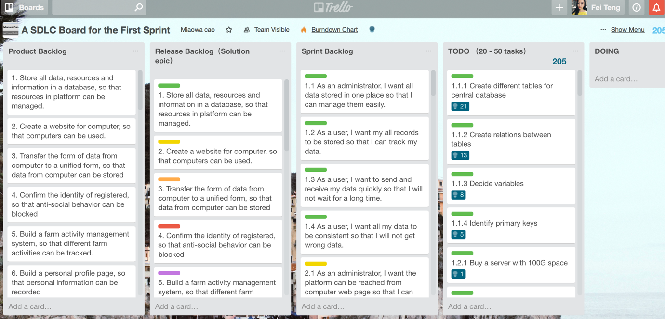

**Screenshot 6 Agile SDLC swimlane board**

Link: https://trello.com/invite/b/0jmA6Luh/b5ee99ff43ceed3232b986763b7a55c8/a-sdlc-board-for-the-first-sprint

### The List of Low-Level User Stories in the First Sprint with Estimated Story Points

|  |  |  |
| --- | --- | --- |
| User Story | Low-level user story | Estimated Story Point |
| 1.1 As an administrator, I want all data stored in one place so that I can manage them easily. | 1.1.1 Create different tables for central database | 21 |
| 1.1.2 Create relations between tables | 13 |
| 1.1.3 Decide variables | 8 |
| 1.1.4 Identify primary keys | 5 |
| 1.2 As a user, I want my all records to be stored so that I can track my data. | 1.2.1 Buy a server with 100G space | 1 |
| 1.3 As a user, I want to send and receive my data quickly so that I will not wait for a long time. | 1.3.1 Build joint tables | 2 |
| 1.4 As a user, I want all my data to be consistent so that I will not get wrong data. | 1.4.1 Create a function for data transfer | 5 |
| 2.1 As an administrator, I want the platform can be reached from computer web page so that I can manage the platform on my computer. | 2.1.1 Build an interface for administrators to register | 3 |
| 2.1.2 Build an interface for administrators to login in | 3 |
| 2.1.3 Build an interface for administrator to manage data | 5 |
| 2.2 As a user, I want to access the platform through my computer so that I can do operations using my computer. | 2.2.1 Build an interface for user to register | 2 |
| 2.2.2 Build an interface for user to use | 2 |
| 2.2.3 Build an interface for user to log in. | 3 |
| 3.1 As an administrator, I want the form of all data to be unified so that the database can be easily maintained. | 3.1.1 Build a function to classify data | 2 |
| 3.1.2 Build a function to open sockets | 2 |
| 3.1.3 Build a function to data receive data | 8 |
| 3.2 As a user, I want the form of all data to be unified so that the system can be more reliable. | 3.2.1 Build a function to send data | 1 |
| 3.2.2 Build a function for data transformation | 2 |
| 4.1 As an administrator, I want users to be divided into active members and observers so that I can manage their limitations. | 4.1.1 Build a function to distinguish the type of users | 8 |
| 4.2 As an administrator, I want active users to provide a valid NGR number so that posts will not be anonymous. | 4.2.1 Build a function to connect to the NGR database | 13 |
| 4.2.2 Build a function to forbid some operation from an unidentified user | 3 |
| 4.3 As a user, I want to have an option to be an observer so that I can see others’ diary entries. | 4.3.1 Build a function to give an observer an authority to view others’ entries. | 3 |
| 4.4 As a user, I want to have an option to be an active user providing my official NGR number so that I can create entries. | 4.4.1 Build a function to accept user’s input “NGR” number | 3 |
| 4.4.2 Build a function to check if the number is in NGR database | 5 |
| 4.4.3 Build a function to give a user certain authority to do some operations | 3 |
| 5.1 As an administrator, I want to manage all farm activities so that illegal activities can be blocked. | 5.1.1 Build a function to read the cache of farm activities | 2 |
| 5.1.2 Build a function to analyse which activities are illegal. | 8 |
| 5.2 As a user, I want to be able to publish my farm activities so that I can see how my farm has performed. | 5.2.1 Build a txt control function to store message | 2 |
| 5.2.2 Build a function for message sending | 2 |
| 5.2.3 Build an API to open sockets | 2 |
| 5.3 As a user, I want farm activities to be recorded so that I can track the activities. | 5.3.1 Build a cache to store small recent data | 2 |
| 5.3.2 Build a function to produce activity page | 3 |
| 6.1 As an administrator, I want to record users’ profile so that I can manage the information of users. | 6.1.1 Build a function to analyse the information of users | 13 |
| 6.2 As a user, I want to be able to publish my personal detail so that others can realize me. | 6.2.1 Build a function for page creation | 2 |
| 6.3 As a user, I want to see other’s personal profile so that I can decide whether I will accept the friend requests. | 6.3.1 Build a function for requests sending | 2 |
| 6.3.2 Build a function for data translation | 5 |
| 7.1 As an administrator, I want to record friendship between users so that I can manage the connection between users. | 7.1.1 Build a joint table in database to record the friendship between users. | 1 |
| 7.2 As a user, I want to search for and connect with other users so that I can see other’s diary entries. | 7.2.1 Build a function for adding friends | 3 |
| 7.2.2 Build a function to recognize your friends in reality | 13 |
| 7.3 As a user, I want to decide whether I will approve the request so that security can be improved. | 7.3.1 Build an option for requests accepted and refused | 2 |
| 7.3.2 Build a chat function | 1 |
| 7.4 As a user, I want to have options to delete connection so that I can end a relationship. | 7.4.1 Build a function for deleting friendship | 1 |
| 7.5 As a user, I want to have options to report others so that anti-social behaviour can be blocked. | 7.5.1 Build an option for reporting other users | 3 |
| 8.1 As an administrator, I want to record comments made between users so that offending users can be removed from the platform. | 8.1.1 Build a function to figure out offending comments | 8 |
| 8.1.2 Build a function to remove offending users | 2 |
| 8.2 As a user, I want to comment on others’ entries so that I can have social interaction with others. | 8.2.1 Build a function to create a comment space | 1 |
| 8.2.2 Build a function to count “likes” | 2 |
| 8.2.3 Build a “like” button | 1 |
| 8.3 As a user, I want to see others’ comments on my diary entries so that I can review my work. | 8.3.1 Build a joint table to store different comments | 1 |

**Table 6 List of Low-Level User Stories with Estimated Story Points**

### Sprint duration, burndown chart

The total story points of tasks for first sprint on SDLC board are 205. Based on our team velocity, which is 90 points a week, the duration we estimate for the first sprint is approximately 3 weeks.

### Describe how to monitor progress using a Burndown Chart and scope creep using a Burnup Chart

A burndown chart shows how much work is remaining to be done in the project. A burnup chart uses two separate lines for completed work and total work. It shows more clearly how much work has been done and the total amount of work. What’s more, a burnup chart shows scope changes clearly. If a client suddenly demands extra features, or some work are removed, the scope will be changed. Although in this project, there are not much demand changes from clients.

## SUMMARY

Our documentation clarifies document purpose, scope of project, audience of document and its limitations. It mainly consists of four sections, which are Project Management Plan, Software Development Life Cycle, Narrative Overview and Solution Overview. These four sections together explain how team Miaowa Cao process the project using agile scrum and relevant tools.

## Reference：

Agile Alliance. (2001). Manifesto for agile software development. Retrieved from http://agilemanifesto.org/

Boehm, B. W. (1988). A spiral model of software development and enhancement. Computer, 21(5), 61-72.

Burn up vs burn down chart. Retrieved from http://www.clariostechnology.com/productivity/blog/burnupvsburndownchart.

Cardozo, E. S., Neto, J. B. F. A., Barza, A., França, A. C. C., & da Silva, F. Q. (2010, April). SCRUM and Productivity in Software Projects: A Systematic Literature Review. In EASE.

Li, J., Moe, N. B., & Dybå, T. (2010, September). Transition from a plan-driven process to scrum: a longitudinal case study on software quality. In Proceedings of the 2010 ACM-IEEE international symposium on empirical software engineering and measurement (p. 13). ACM.

North, D. (2009). The perils of estimation. Retrieved from https://dannorth.net/2009/07/01/the-perils-of-estimation/.